Related work

Gait Analysis and Gait Disorders
Human gait depends on a complex interplay of major parts of the nervous, musculoskeletal and cardiorespiratory systems. A person’s gait pattern is strongly influenced by age, personality, and mood. Moreover, sociocultural factors play a role: for instance, persons living in large cities walk significantly faster than those living in rural areas [1]. Walking is a sensitive indicator of overall health status and the self-selected walking speed closely correlates with individual life expectancy in elderly persons [2].
The causes of gait disorders include neurological conditions (e.g., sensory or motor impairments), orthopedic problems (e.g., osteoarthritis and skeletal deformities) and medical conditions (e.g., heart failure, respiratory insufficiency, peripheral arterial occlusive disease and obesity). In older age, gait disorders typically have several causes, which may include impaired proprioceptive function in polyneuropathy, poor vision, frontal gait disorder associated with vascular encephalopathy and osteoarthritis of the hips or knees. If a gait disorder has an acute onset, cerebrovascular, spinal and neuromuscular causes should be considered, as should adversely drug effects and psychiatric disorders. Possible medical causes include cardiorespiratory or metabolic disturbances and infections [3].

Gait disorders in adults and the elderly
To analyze gate pattern in terms of normal and pathological we need a definition and parameters that describe them. An article published in 2016 by Walter Pirker and Regina Katzenschlager [4] provides an overview on the phenotypic spectrum, work-up and treatment of gait disorders. It describes the physiological basis of gate, clinical examination of gate and gate disorders classifications.
Initiating gait requires a stable upright body position, functioning postural reflexes are necessary to assume and sustain a stable body position. To start walking, one leg is raised and directed forward by flexing the hips and knee. Activation of the supporting contralateral leg and trunk muscles moves the body’s center of gravity over the weight-bearing leg and forward. The heel of the swinging leg is then placed on the ground. The body weight is gradually shifted to the sole and then onwards to the toes. During mid-stance, the opposite leg is lifted and moves forward until the heel strikes the ground. Meanwhile, the body is held upright, the shoulders and pelvis remain relatively level and each arm swings in the direction opposite to that of its ipsilateral leg.
The gait cycle (Figure 10) is divided into the stance and swing phase [5][6]. The stance phase constitutes approximately 60 % of the gait cycle and is subdivided into:
- initial contact (heel strike).
- loading response.
- mid-stance.
- terminal stance.
- pre-swing.
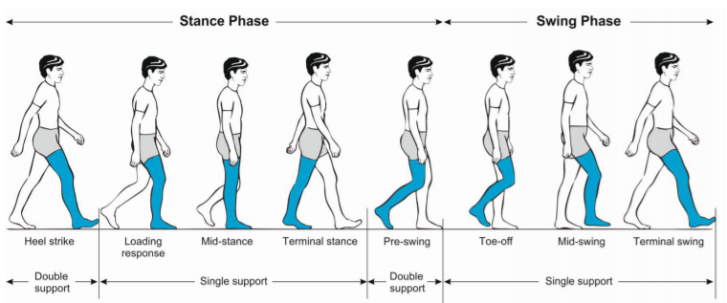
Both feet are on the ground at the beginning and end of the stance phase. Each of these two double support periods lasts for approximately 10–12 % of the gait cycle. The swing phase takes up about 40 % of the gait cycle and is subdivided into:
Figure 1 Phases of normal gate cycle [4]

- initial swing (toe off).
- mid-swing (tibia vertical).
- terminal swing, terminated by the heel striking the ground.
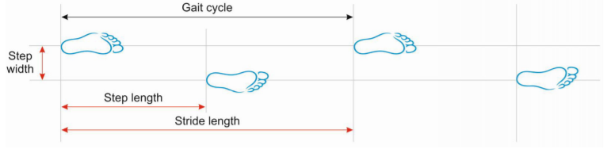
Figure 2 Basic terminology describing the gate cycle [4]
Important measures of gait (Figure 11) include:
- walking speed.
- cadence (number of steps per unit of time).
- walking base width (measured from midpoint to midpoint of both heels).
- step length (measured from the point of foot contact to the point of contralateral foot contact).
- stride length (linear distance covered by one gait cycle).
The preferred walking speed in healthy adults up to the age of 59 years is approximately 1.4 m/s [7]. Average stride lengths in healthy adults’ range between 150 and 170 cm. The average cadence in young adults was reported to range between 115 and 120 steps/min. Ageing is associated with a decline in gait speed and step length whereas cadence remains relatively stable. Elderly subjects prefer a 40 % wider step width than young persons (average step width in elderly women approximately 8 cm and in elderly men 10 cm) [8].
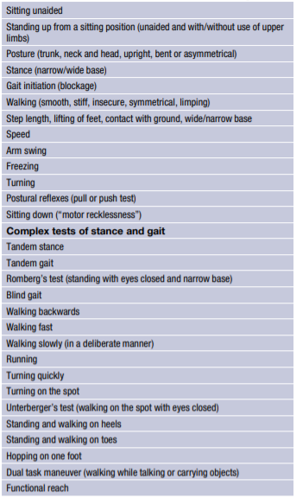
Clinical examination of gait provides an overview of the function of the structures involved in walking. In the examination process it is important to observe the entire patient, from the front and from all sides, while walking over a distance of at least several meters without obstacle and it is recommended that the patient wont were shoes. Table 1 summarizes the parameters that should be clinically examined, which include step length, stride length, step width, rhythm, speed, posture, swinging of arms and legs and the duration and type of contact with the floor [9].
Table 1 Parameters for the clinical examination of gate [4]
The Bruneck study, in which a representative sample of the population of a small region in northern Italy is being followed longitudinally, has provided valuable epidemiological data on various gait disorders in 488 persons: between the ages of 60 and 97 years one third of this population had a gait disorder, with a marked increase in prevalence with age, between the ages of 60 and 69 years, the prevalence was 10 % and in those over 80 years it was >60 % [14]. In two thirds of those affected by any gait disorder, the cause was neurological and in approximately one half, the cause was nonurological, indicating that there was a considerable overlap of patients affected by neurological as well as by non-neurological gait disorders. Among the neurological causes, sensory ataxia (18 %) and parkinsonian (16 %) gait disorders were the most common, followed by frontal (8 %), cerebellar ataxic gait disorders, cautious gait and hypotonic paretic, spastic, vestibular and dyskinetic gait disorders. In approximately one third of the patients the gait disorder was due to more than one neurological cause, making a precise classification difficult [14]. It must be pointed out that these prevalence rates refer to elderly people living in the community. Substantially higher rates of gait disorders are to be expected among geriatric hospital and nursing home residents [18].
The article reviews several common gate disorders and their phenomenological classification (table 2). The gate disorders can be divided into the following categories:
- Musculoskeletal gait disorders: Osteoarthritis and skeletal deformities of the lower extremities are the most common reasons for non-neurological gait disorders in adults [14]. The resulting orthopedic gait disturbances may be characterized by a limited range of motion, avoidance of weight-bearing and asymmetry or limping.
- Neuromuscular and myelopathic gait disorders: Peripheral paresis that is severe enough to cause a gait disorder can usually be detected on standard clinical neurological examination.
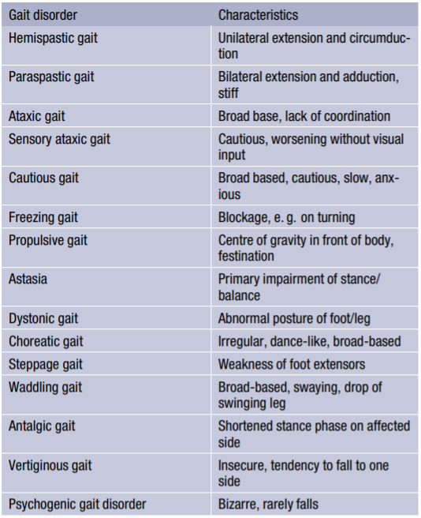
- Gait disorders associated with brain dysfunction: This category encompasses all gait disorders related to brain disease or dysfunction, i.e., the neurological gait disorders in a narrower sense. It largely overlaps with the categories of middle and higher-level gait disorders in the classification proposed by Nutt et al. [15–17]; however, some middle level gait disorders, such as spastic gait may also be caused by spinal lesions.
Table 2 Table 2 Phenomenological classification of gait disorders
(modified from Ru ˇzi ˇcka and Jankovic [13].
Any gait disorder should be thoroughly investigated to improve patient mobility and independence, to prevent falls and to detect the underlying causes as early as possible. Thorough clinical observation of gait, careful history taking focused on gait and falls, and physical, neurological and orthopedic examinations are basic steps in the categorization of gait disorders and serve as a guide for ancillary investigations and therapeutic interventions. Several gait disorders are amenable to specific treatment. Levodopa is the drug of choice for the treatment of the gait disorder of PD and in some other parkinsonian syndromes. Rare conditions, such as myoclonus and orthostatic tremor also may respond well to medication. In normal pressure hydrocephalus, cervical spondylitis myelopathy, lumbar spinal stenosis and hip or knee osteoarthritis, surgical treatment should be considered. Patients with gait disorders not amenable to specific treatment (e. g. many neuromuscular conditions, frontal gait disorders) may benefit from multimodal rehabilitation, gait training, use of assistive devices and fall prevention measures. Commonly used exercise interventions such as muscle strength, power, and resistance training as well as coordination training can improve habitual and maximum gait speed in elderly subjects [19]. These exercise programs can be individualized according to the type of gait impairment, the therapist’s experience, and patient’s preferences.

During gate, three main events occur in which energy is consumed. This includes controlling forward movement during deceleration toward the end of swing phase, shock absorption at heel strike, and propulsion during push off, when the center of gravity is propelled up and forward [10][11]. The least amount of energy is required when a body moves along a straight line, with the center of mass deviating neither up nor down, nor side to side. The center of mass is located just anterior to the second sacral vertebra, midway between both hip joints. Our COM deviates from the straight line in vertical and lateral sinusoidal displacements. It goes through rhythmic upward and downward motion as it moves forward. The highest point occurs at midstance, the lowest point occurs at time of double support. The average amount of vertical displacement in the adult male is approximately 5 cm. With respect to lateral displacements as weight is transferred from one leg to the other, there is shift of the pelvis to the weight-bearing side. The oscillation of the COM amounts to side-to-side displacement of approximately 5 cm. The lateral limits are reached at midstance [12].
- Ebersbach G, Sojer M, Muller J, Heijmenberg M, Poewe W. Sociocultural differences in gait. Mov Disord. 2000;15(6):1145–7.
- Studenski S, Perera S, Patel K, Rosano C, Faulkner K, Inzitari M, et al. Gait speed and survival in older adults. JAMA. 2011;305(1):50–8.
- Alexander NB, Goldberg A. Gait disorders: search for multiplecauses. CleveClin JMed. 2005;72(7):586.
- Pirker, W., Katzenschlager, R. Gait disorders in adults and the elderly. Wien Klin Wochenschr 129, 81–95 (2017). https://doi.org/10.1007/s00508-016-1096-4
- Ružicka E, Jankovic JJ. Disorders of gait. In: Jankovic ˇ JJ, Tolosa E, editors. Parkinson’s disease and movement disorders, 4th edn. Philadelphia: Lippincott, Williams and Wilkins; 2002. pp. 409–29.
- Lim MR, Huang RC, Wu A, Girardi FP, Cammisa FP Jr.. Evaluationof theelderlypatientwithanabnormalgait. JAm AcadOrthop Surg. 2007;15(2):107–17.
- Bohannon RW, Williams Andrews A. Normal walking speed: a descriptive meta-analysis. Physiotherapy. 2011;97(3):182–9.
- Aboutorabi A, ArazpourM, BahramizadehM,Hutchins SW, Fadayevatan R. The effect of aging on gait parameters in able-bodied older subjects: a literature review. Aging Clin ExpRes. 2015;doi:s40520-015-0420-6.
- Snijders AH, van de Warrenburg BP, Giladi N, Bloem BR. Neurological gait disorders in elderly people: clinical approach andclassification. LancetNeurol. 2007;6(1):63–74.
- Klopsteg PE, Wilson PD, editors. Human limbs and their substitutes. New York: McGraw-Hill; 1954
- Inman VT. Conservation of energy in ambulation. Arch Phys Med Rehabil 1967 ;47 :484—8.
- Malanga and A. DeLisa. “Clinical Observation.” (2005).
- Ružicka E, Jankovic JJ. Disorders of gait. In: Jankovic ˇ JJ, Tolosa E, editors. Parkinson’s disease and movement disorders, 4th edn. Philadelphia: Lippincott, Williams and Wilkins; 2002. pp. 409–29.
- Mahlknecht P, Kiechl S, Bloem BR, Willeit J, Scherfler C, Gasperi A, et al. Prevalence and burden of gait disorders in elderly men and women aged 60–97 years: a populationbasedstudy. PLOSONE. 2013;8(7):e69627.
- Nutt JG, Marsden CD, Thompson PD. Human walking and higher-level gait disorders, particularly in the elderly. Neurology. 1993;43(2):268–79.
- Nutt JG. Classification of gait and balance disorders. Adv Neurol. 2001;87:135–41.
- Nutt JG. Higher-level gait disorders: an open frontier. Mov Disord. 2013;28(11):1560–5.
- Sudarsky L. Gait disorders: prevalence, morbidity, and etiology. AdvNeurol. 2001;87:111–7.
- Hortobagyi T, Lesinski M, Gabler M, VanSwearingen JM, Malatesta D, Granacher U. Effects of three types of exercise interventions on healthy old adults’ gait speed: A systematic review and meta-analysis. Sports Med. 2015;45(12):1627–43.

Object detection and classification with yolo
There has been much work in developing YOLO based object detection algorithms using a standard camera with no additional sensors.

YOLO-Tomato: A Robust Algorithm for Tomato Detection Based on YOLOv3
Guoxu Liu, Joseph Christian Nouaze, Philippe Lyonel Touko Mbouembe and Jae Ho Kim [1] proposed an improved tomato detection model called YOLO-Tomato based on YOLOv3 to deal with automatic fruit detection in complicated environment conditions. The model overcomes environment conditions like illumination variation, branch, leaf occlusion and tomato overlap. The suggested method was achieved through two approaches, the first incorporated the dense architecture for feature extraction, which can make better reuse of features and help to learn more accurate models. The second replaced the traditional R-Bbox with a proposed C-Bbox, better matching the tomato shape and providing more precise IoU for the NMS process, and reducing prediction coordinates.
The tomato datasets used in the paper were collected in a period from December 2017 to November 2019 in Vegetable High-tech Demonstration Park, Shouguang, China. The images were captured using a digital camera (Sony DSC-W170, Tokio, Japan) with a 3648 _ 2056-pixel resolution. All the images were taken under natural daylight conditions, including several disturbances: illumination variation, occlusion, and overlap. A total of 966 tomato images were captured and divided into a training set and a test set. The training set consisted of 725 images which contained 2553 tomatoes, and the remaining 241 images which included 912 tomatoes made up the test set. Figure 3 shows some samples from the dataset under different environments.
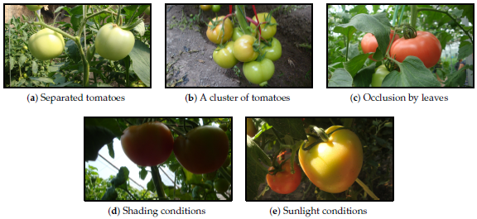
Figure 5Tomato samples with different growing circumstances: (a) two separated tomato, (b) a cluster of tomatoes, (c) occlusion case, (d) shading conditions and (e) sunlight conditions.
The data augmentation technique was used in this study. While training, before input into the model, each image was randomly sampled by the entire original image or scaling and cropping. For the scaling and cropping operation, the image was first scaled with a random factor falling in the range [1.15, 1.25]. Then, a patch with the same size as the original image was randomly cropped from the scaled image. After the sampling step, each image was horizontally flipped with a probability of 0.5. Some examples of the augmentation are shown in Figure 4.
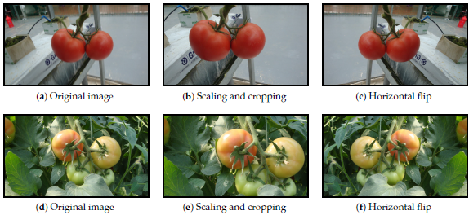
Figure 6 Some examples of image augmentation operations: (left) original images, (middle) scaling and cropping, and (right) horizontal flip.
An overview of the proposed tomato detection model is shown in Figure 5. Based on the YOLOv3 model, a dense architecture was incorporated for better feature reuse and representation. Furthermore, a C-Bbox was proposed instead of the traditional R-Bbox. The C-Bbox can match the shape of a tomato better, consequently making a more precise localization. Moreover, the C-Bbox can derive a more accurate IoU between the predictions, which plays an important role in the NMS process, and thus improve the detection results. The proposed model is called YOLO-Tomato. Figure 6 shows a flowchart of training and detection process of YOLO-Tomato.
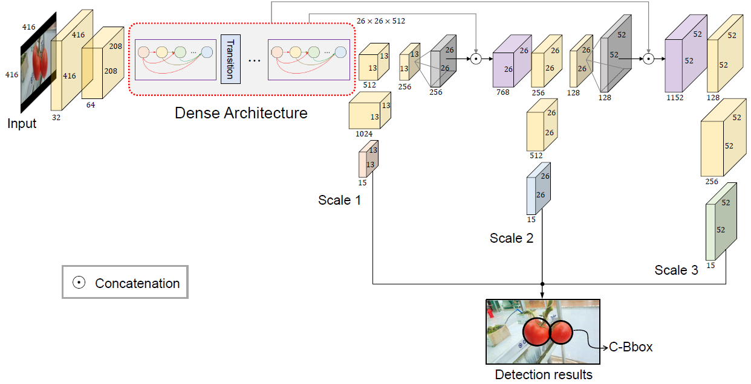
Figure 7 An overview on the proposed method
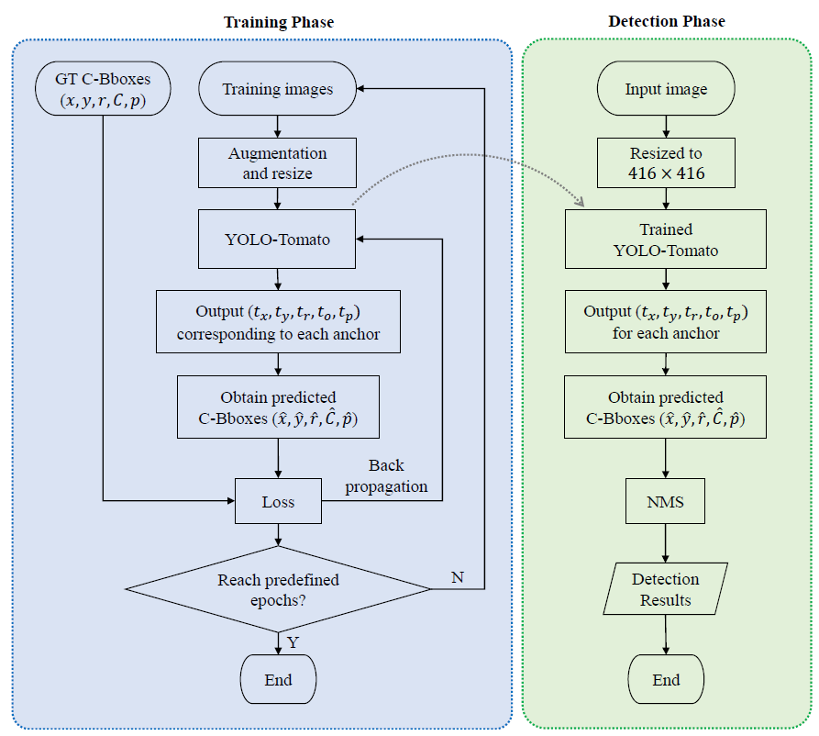
Figure 8 A flowchart of training and detection process of YOLO-tomato.
To better reuse the features for tomato detection, a densely connected architecture is incorporated into the YOLOv3 framework, as in Figure 5. With this modification, the extracted features can be utilized more efficiently, especially for those from low-level layers, which can be expected to improve the accuracy of detection. There are five dense blocks in this architecture, which consists of 6, 12, 24, 16, and 16 dense layers, respectively. For each dense layer, a 1 _ 1 bottleneck layer [2] and a 3 _ 3 convolutional layers are stacked together. To make the model more compact, a transition layer was placed between any two consecutive dense layers. Owing to the direct connection between any two layers inside the dense block, the network can learn more rich features and improve the representation of tomatoes. The structure of a dense block is illustrated in Figure 7.
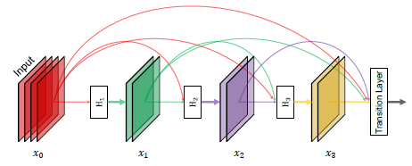
Figure 9 A 4-layer dense block. Each layer takes all preceding feature-maps as input and serves as input for all subsequent layers. Hi denotes the operation BN-ReLU-Conv1_1-BN-ReLU-Conv3_3.
In the original YOLOv3 model, there are six convolutional layers in front of each of the detection layers. Due to the better use of features by dense architecture, the original six layers were pruned to two layers before each detection layer, by removing the first four layers.
Since the detection target in this article is tomato (a circle shape), a C-Bbox is proposed. Due to the better match of tomatoes and the C-Bboxes, it is believed the proposed C-Bbox has two main advantages when compared to the traditional R-Bbox. On one hand, the IoU of two predicted C-Bboxes is more accurate than that of R-Bboxes. On the other hand, the C-Bbox has less parameters than R-Bbox, making it easier for the CNN model to regress from the prior anchors to the predictions.
Different experiments were conducted to verify the performance of the proposed method. An ablation study of the dense architecture and C-Bbox showed the effectiveness of each modification. Incorporating dense architecture could contribute about 2% improvement on F1 score. Based on the dense architecture, a further adoption of C-Bbox could contribute another 0.65% improvement on the F1 score.
Experiments under different illumination and occlusion conditions were also conducted. The proposed model showed comparable results under both sunlight and shading conditions. This indicates the robustness of the model to illumination variation.
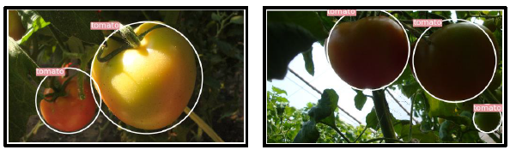
Figure 10 Some examples of the detection result under different lighting conditions.
The model shows a divergence under different occlusion conditions. Under slight occlusion conditions, the correct identification rate of YOLO-Tomato reaches 94.58%. This is more than 4% higher than that of severe conditions. This was mainly attributed to the loss of semantic information by severe occlusion.

YOLO based Human Action Recognition and Localization [3]
The article proposes a YOLO-based approach to detect, localize and recognize actions of interest in almost real-time from frames obtained by a continuous stream of video data that can be captured from a surveillance camera. The model takes input frames after a specified period and can give action label based on a single frame. Combining results over specific time allows to predict the action label for stream of video.
The dataset used in their paper is LIRIS human activities dataset [4]. The dataset contains the videos in form of RGB frames. The annotations provided are in form of an XML file. The dataset is ideal for processing video based on surveillance camera. There are 10 visual annotated actions which include human-human, human-object, and human-human-object interactions. Table 1 shows the list of action categories in LIRIS dataset. The dataset contains 367 actions from 167 videos. These 167 videos are further divided into 109 training and 58 testing videos. Per class ratio of training to test data is kept approximately 2:1. Figure 4 shows some of the frames in LIRIS dataset.
Table 3 The action categories in LIRIS dataset.
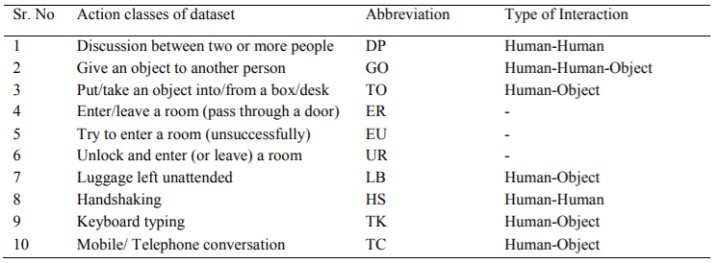
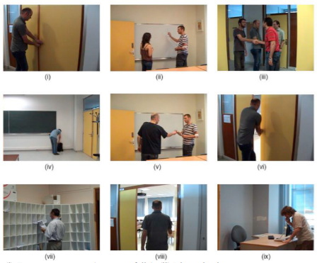
Figure 11 Frames in LIRIS dataset (i) Try to enter a room (unsuccessfully), (ii) Discussion between two or more people, (iii) Handshaking, (iv) Leave baggage unattended, (v) Give an object to another person, (vi) Unlock and enter (or leave) a room , (vii) Put/take an object into/from a box/desk, (viii) Enter/leave a room (pass through a door), (ix) Telephone conversation.
The flowchart for training of YOLO based action recognition model is shown in Figure 10. To train the model they converted the LIRIS dataset labels to usable label files for YOLO. YOLO requires a .txt file for each frame with a line for each action in the frame. Further YOLO requires some files to start training which are: Total number of action classes, text file with the path to all frames which we want to train, text file with names of all action classes, the path to save trained weight files, a configuration file with all layers of YOLO architecture and pre-trained convolutional weights. The value of filters in the configuration file of YOLO (.cfg file) for second last layer is not arbitrary and depends on the total number of classes [5]. The number of filters can be given by equation (1).
- $filters=5*\left(2+number_{of_{classes}}\right)$
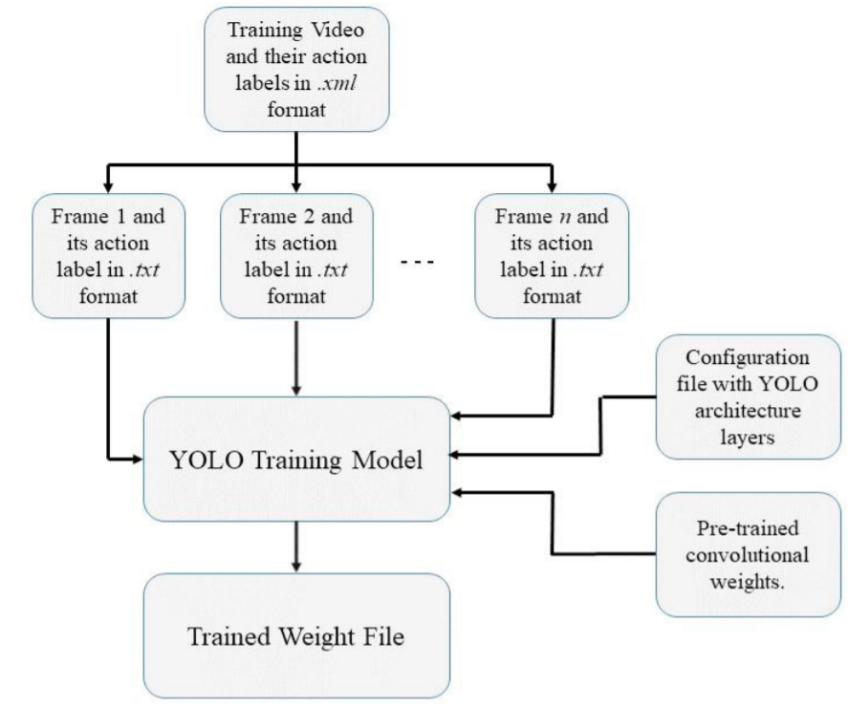
Figure 12 The flowchart for training of YOLO.
The workflow implemented for this paper described in Figure 9. The model was trained using frames containing appropriate action, from the training set of LIRIS dataset. For testing purpose, 30 frames in a video were selected for recognition and localization of action, from the testing video frames. These frames are chosen after a period of a certain number of frames which depends upon the total number of frames in the video. After performing action detection on each frame, the action label detected in more than 5 frames and having a confidence threshold of 0.5 over 30 frames is classified as concluding action label in the video. The combined confidence score of the action label overall is calculated by averaging all confidence score obtained.
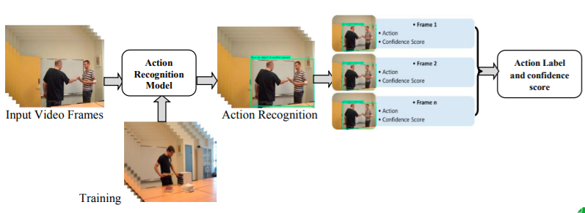
Figure 13 Workflow of the algorithm
In training process, each iteration took about 5.25s. The model was trained up to 40000 iterations and average loss was found to be 0.32 for the batch size of 32 with 8 subdivisions. For testing, average recognition of action in frame takes about 61ms that is 15-16 FPS (Frame per second). Hence, Real-time recognition of action is feasible on off-the-shelf desktop PCs with a mid-level Graphics Processing Unit (GPU).
The accuracy obtained on the test dataset is the primary evaluation metric for classification in the paper. The confusion matrix is used to calculate Precision, Recall, F-score and overall Accuracy of the model. Confusion matrix obtained on test dataset is shown in Table 2, where rows represent actual actions while column represents the predicted actions. Most classification results are concentrated along the diagonal. The accuracy obtained by methodology proposed in this paper was found to be 88.372%. Precision, Recall, F-score for each action class is presented in Table 3. Table 4 indicates that proposed method performs better when compared F-scores of state-of-art methods.
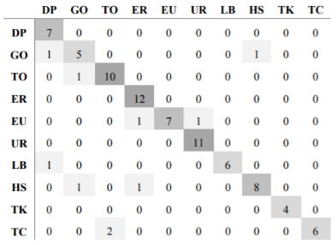
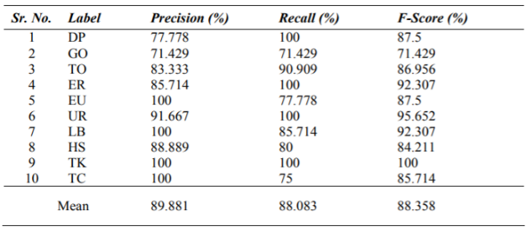
Table 5 The confusion matrix obtained.
Is shows the classification accuracy on
LIRIS human activity dataset.
Table 4 Precision, Recall, F-score for each action class using confusion matrix.

Table 6 Comparison of performance with the state-of-the-art methods (F-score for action recognition and localization).
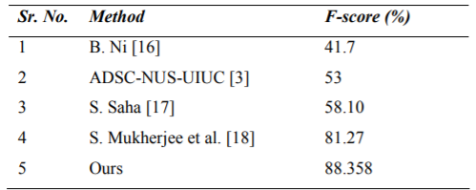
The main finding of their study is that the proposed real-time model for human action recognition in video based on YOLO allows to recognize actions in a video even with a small number of frames. Example of action detection are shown in figure 12.
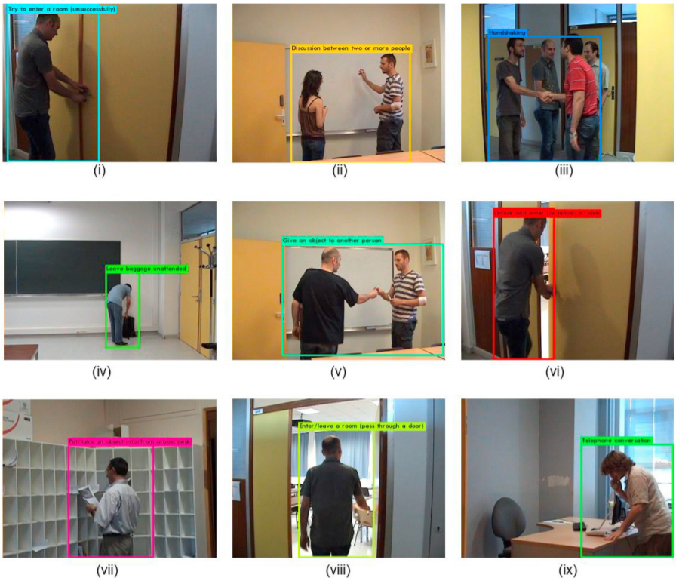
Figure 14 Recognition and Localization of actions.
- Sensors, EISSN 1424-8220, Published by MDPI
- He, K.; Zhang, X.; Ren, S.; Sun, J. Deep residual learning for image recognition. In Proceedings of the IEEE Conference on Computer Vision and Pattern Recognition, Las Vegas, NV, USA, 30 June 2016; pp. 770–778.
- Shinde, Shubham & Kothari, Ashwin & Gupta, Vikram. (2018). YOLO based Human Action Recognition and Localization. Procedia Computer Science. 133. 831-838. 10.1016/j.procs.2018.07.112.
- C Wolf, J. Mille, E. Lombardi, O. Celiktutan, M. Jiu, E. Dogan, G. Eren, M. Baccouche, E. Dellandrea, C.-E. Bichot, C. Garcia, B. Sankur, Evaluation of video activity localizations integrating quality and quantity measurements, In Computer Vision and Image Understanding (127):14-30, 2014.
- “Start training YOLO with our own data” [Online, Accessed on Mar 12, 2018]. Available at: http://guanghan.info/blog/en/my-works/trainyolo/

Skeleton extraction from natural images
Skeleton extraction from natural images is very challenging problem because it requires the extractor to be able to capture both local and non-local image context in order to determine the scale of each skeleton pixel.

- A. Sironi, V. Lepetit, and P. Fua, “Multiscale centerline detection by learning a scale-space distance transform,” in Proc. CVPR, 2014, pp. 2697–2704.

